**Analysis of factors affecting graduation rates across the top 5 colleges and universities in Florida**



**Team Members:**

* Bridgette Sanders
* Cheikh Sidi El Moctar
* Lisette Cruz
* Ricardo Kenny

**Introduction:**

There have been many studies done around which factors affect the graduation rate for college students. Our group focused on four factors, which we believe have a direct correlation on the graduation rates.

This project is an analytical project, our aim is to analyze graduation rate data and any related data to explore what drive the graduation rate, within the targeted universities.

**Questions:**

* + Are the ACT, SAT scores related to the graduation rate, and how?
  + Does the college cost affect to the graduation rate and how?
  + Does the Acceptance rate affect the graduation rate, and how?
  + Does the total student population (school size) affect the graduation rate?

**Hypothesis:**

* + School size may affect graduation rates since smaller schools usually have a smaller student body; thus, smaller class sizes. This most often means more individualized attention for each student.
  + Universities requiring an above average ACT/SAT may have higher graduation rates as these are the students that are good test takers which will be reflected in the classroom; thus, positively impacting graduation rate.
  + Universities with higher acceptance rates may translate to lower graduation rates as a higher acceptance rate may mean that the admission requirements are low.
  + Cost of Tuition will affect graduation rates since higher tuition costs may deter students from graduating to prevent further accumulation of debt.

**Resources:**

* Each team member utilized the Project 1 file to begin their analysis.
  + - This dataset comes directly from <https://www.collegetuitioncompare.com/compare/tables/>
    - Other than reducing the dataset to include only necessary data, this dataset was well formatted and required minimal cleaning.

The below tables are extracted from the data frame pulled from the college compare website with link above.

* + 2019_Acceptence.csv (cleaned and reformatted)
  + 2019_ACT_test.csv (cleaned and reformatted)
  + 2019_Graduation.csv (cleaned and reformatted)
  + 2019_Tuition_Fees.csv (cleaned and reformatted)

**Limitations**

* + Time constraint.
  + Incomplete data
  + Data quality.

**Analysis Approach and Tools**

* + Set Clear Measurement Priorities
  + Tools:
    - Pandas
    - Matplotlib
    - SciPy. Stats
    - Seaborn
    - Git, GitHub
  + Data acquisition by scraping using Pandas
    - Data source: 2019 Acceptance Rate Comparison between Colleges in Florida
    - Pandas scrapping
  + Data Cleaning, messaging, and visualization
    - Filtering Florida from the dataset using Pandas
    - Filtering the Florida dataset for target universities (top 5 universities).
    - The following tables were cleaned and filtered:
      * Graduation Rate
      * Acceptance Rate
      * SAT & ACT test Scores
      * Tuition Fees
      * Student Population
  + Analysis
  + Finding Interpretation
  + Conclusion

**Analysis Summary:**

We initially decided to do our project on the which factors effect graduation rates among colleges and universities in all 50 states, but after we started looking at different websites, we determined that due to time constraints, and heterogeneity of colleges, we decided to focus on the top five public universities in Florida. We chose public universities in all four corners of the state to get an overall picture of the data. The institutions chosen were, Florida State University, University of Central Florida, University of Florida, University of South Florida, and Florida International University.

The factors we chose were acceptance rates, student population, tuition, and ACT/SAT test scores. Each factor was measured against the graduation rates to determine if there was any correlation between the two. Listed below are the results of our findings.

Initial data visualization using pandas was performed on the cleaned data, and the following graphs were created.

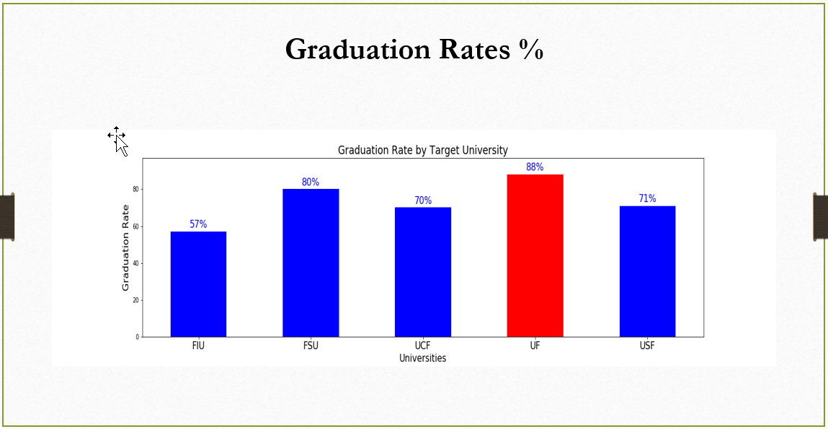

The figure above represents the graduation rate across the top 5 target universities, with top graduation rate at UF, followed by FSU, and UCF.

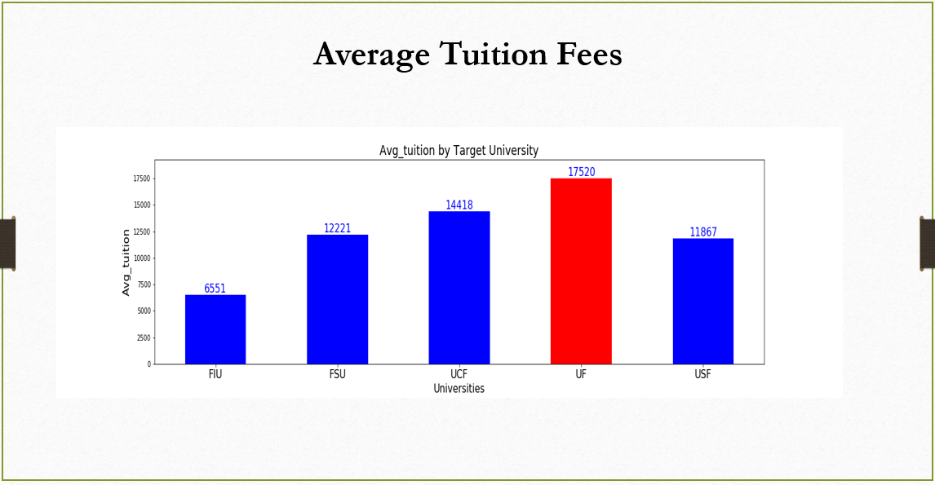

The figure above represents the tuition fees across the top 5 target universities, with top tuition fees at UF, followed by UCF.

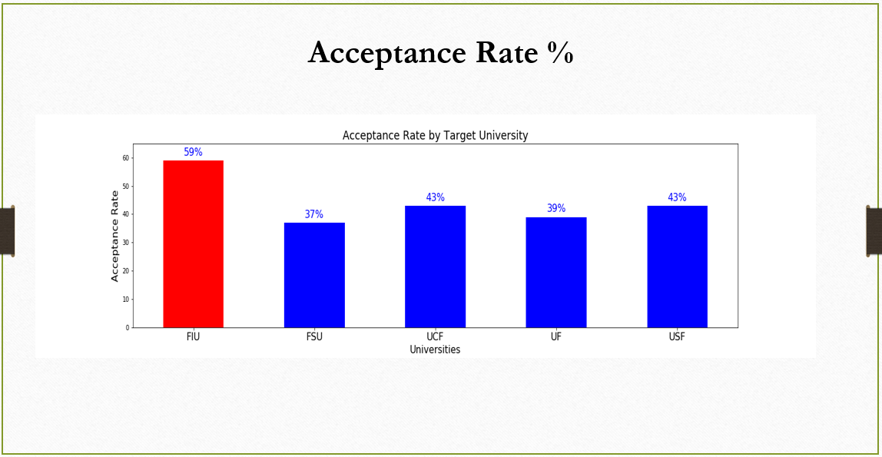

The figure above represents the Acceptance rate across the top 5 target universities, with top acceptance rate at FIU.

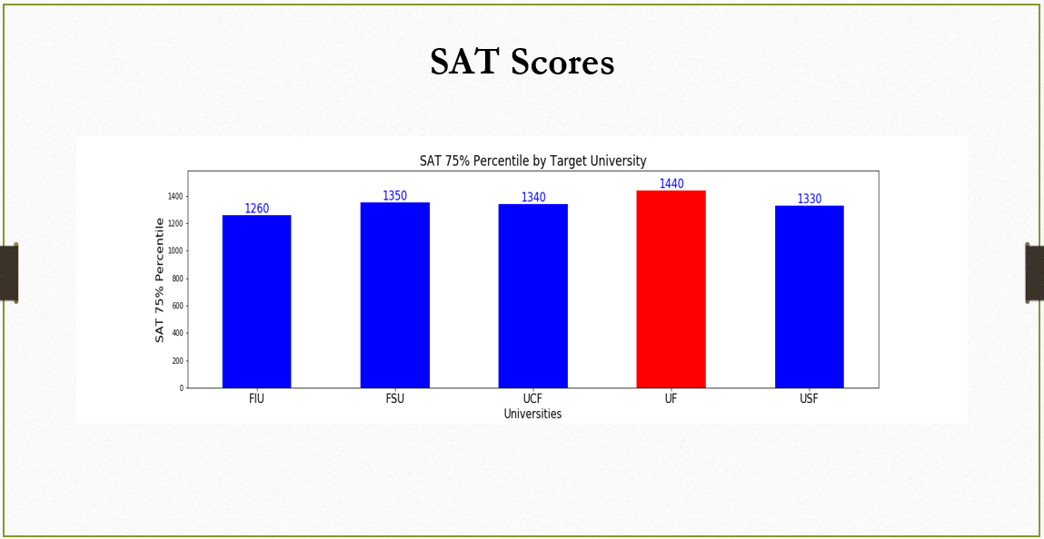

The figure above represents the 75% percentile SAT score across the top 5 target universities, with top scores at UF, followed closely by FSU and UCF.

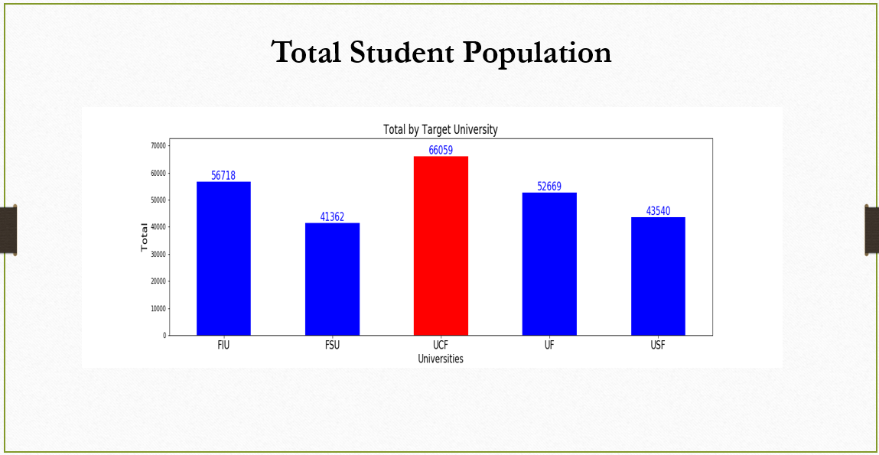

The figure above represents the total students across the top 5 target universities, with top total students at UCF, followed FIU.

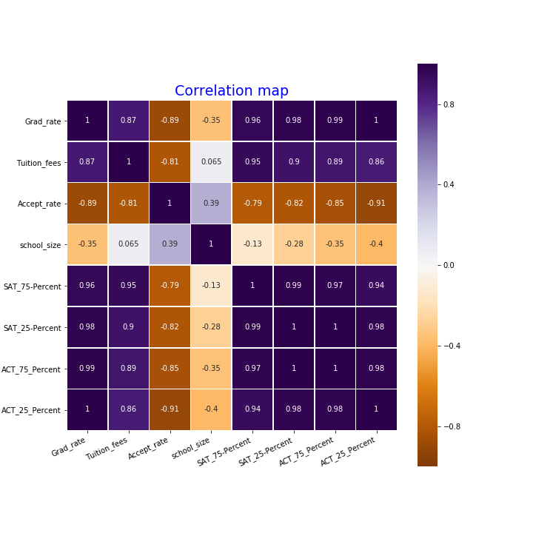

Given the data we have, we were not able to run a t-test to test the Null Hypothesis.

The heat map pictured shows a correlation between all the variables. The darker violet color the more positive correlation and the darker orange the more negative correlation.

* Strong positive correlation between the SAT, ACT test scores, Avg Tuition and graduation rates.
* Strong negative correlation between Graduation Rate and Acceptance Rate.
* Little to no correlation between Graduation Rate and Total Student Population.

We can see the above correlations in detail with the individual scatter plots below.

* + Hypotheses (1) School size may affect graduation rates since smaller schools usually have a smaller student body; thus, smaller class sizes. This most often means more individualized attention for each student.

We found that there is no evidence that school size has a direct impact on graduation rates. The scatter plot shows there is no correlation between the two.

* + Hypotheses (2) Universities requiring an above average ACT/SAT may have higher graduation rates as these are the students that are good test takers which will be reflected in the classroom; thus, positively impacting graduation rate.

Based on our limited data, we found this to be true. The graphs below show a strong positive correlation between high ACT/SAT scores and graduation rates.

Hypotheses (3) Universities with higher acceptance rates may translate to lower graduation rates as a higher acceptance rate may mean that the admission requirements are low.

Based on the scatterplot below: This shows a strong negative correlation between graduation rates and acceptance rates, the lower, the graduation rates, the higher the acceptance rates are.

* Hypotheses (4) Cost of Tuition will affect graduation rates since higher tuition costs may deter students from graduating to prevent further accumulation of debt.

The graph below shows a strong positive correlation between the cost of tuition and graduation rates. The higher the tuition costs, the higher the graduation rates are.

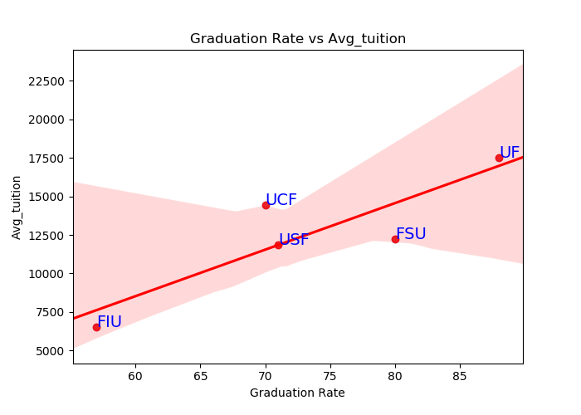

In conclusion, we want to note the while we found positive and negative relationships between graduation rates and the factors we noted, a more thorough analysis would result in more accurate and granular findings. Our timeframe was very limited and thus we had reduced the scale of this project.